27) Aim: Design Turing Machine using simulator to accept the input string wcw over set {a,b).

Diagram:

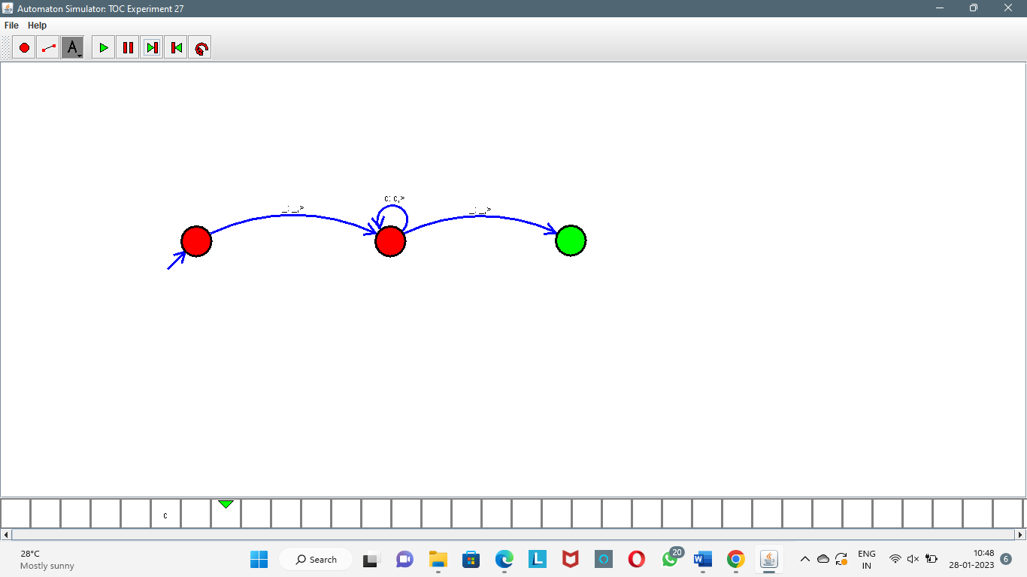

Result:

Successfully executed Turing Machine using simulator to accept the input string wcw over set {a,b).